**DAILY ONLINE ACTIVITIES SUMMARY**

|  |  |  |  |  |  |  |  |  |
| --- | --- | --- | --- | --- | --- | --- | --- | --- |
| **Date:** | **27-06-2020** | | | | | **Name:** | **Pallavi** | |
| **Sem & Sec** | **6th - A** | | | | | **USN:** | **4AL17CS056** | |
| **Online Test Summary** | | | | | | | | |
| **Subject** | | **DBMS and SQL**  **Java and J2EE** | | | | | | |
| **Max. Marks** | | **-** | | **Score** | | | **-** | |
| **Certification Course Summary** | | | | | | | | |
| **Course** | - | | | | | | | |
| **Certificate Provider** | | | **-** | | **Duration** | | | **-** |
| **Coding Challenges** | | | | | | | | |
| **Problem Statement: 1 C program** | | | | | | | | |
| **Status: executed** | | | | | | | | |
| **Uploaded the report in GitHub** | | | | | **Yes** | | | |
| **If yes Repository name** | | | | | <https://github.com/PreethiNayak/Daily-Status/tree/master/27June2020> | | | |
| **Uploaded the report in slack** | | | | | **Yes** | | | |

Online Test Details: (Attach the snapshot and briefly write the report for the same)

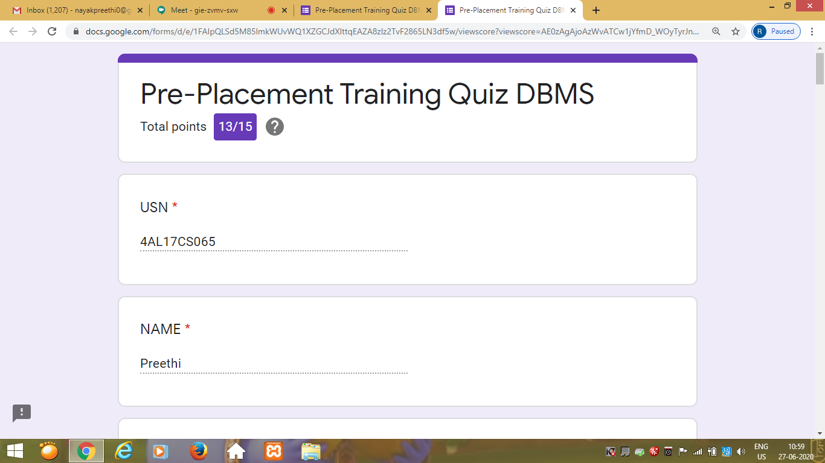

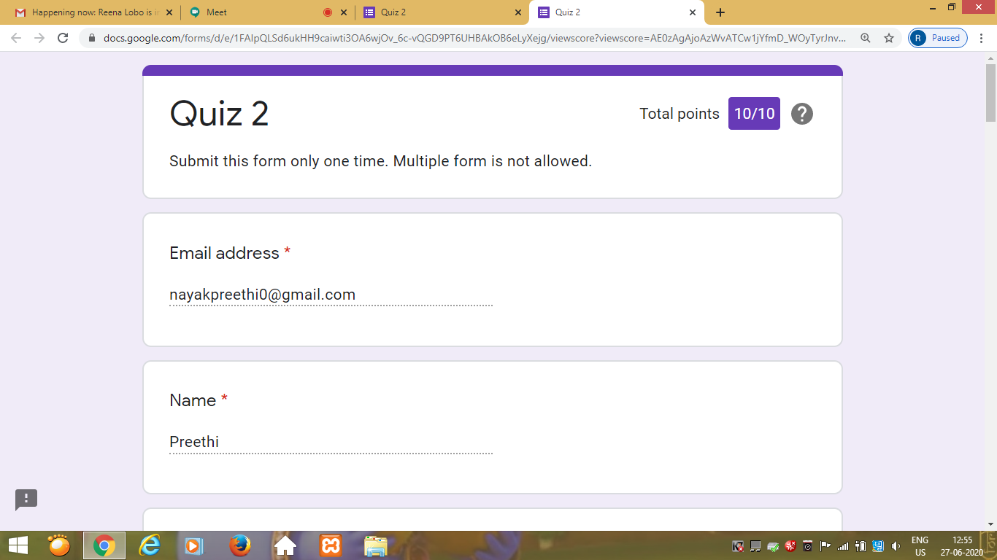

Coding Challenges Details: (Attach the snapshot and briefly write the report for the same)

Program 1

This is output of C program  to implement circular queue using SLL.

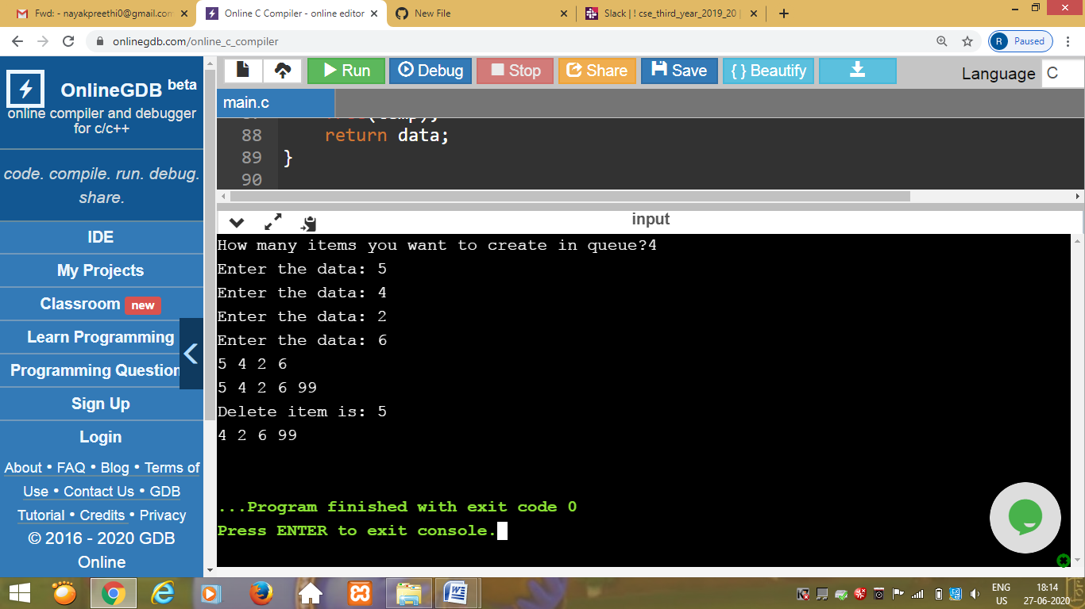

**DBMS and SQL:-**

Today’s activity is uploaded in :-

[https://github.com/pallavi056/DAILY_STATUS/blob/master/27-6-2020/schema%20and%20er(pallavi).pdf](https://github.com/pallavi056/DAILY_STATUS/blob/master/27-6-2020/schema and er(pallavi).pdf)